**Images and dimensions**

***By Rashmi Mishra***

Computers have become one of the most powerful tool for rapid and economical production of pictures, we can find computer graphics playing a big role in areas such as science, engineering, medicine, business, industry, government, art, entertainment, advertising, education and training.

Now, the main important aspect of computer graphics is dimensions.

Can you imagine, how point was considered into one dimension system then line into two and so on.

Let’s discuss about this, Talking about a point represented in two dimensions by it’s coordinates. These two values are specified as the element of a 1-row and 2-columns which is represented as [x y], same point with some z coordinate goes to three dimensions which is a matrix of 1-row and 3-columns which will be represented by [x y z], and these are knowns as position vectors and these vectors relative to some coordinate system, is stored in computer in the form of matrix or array.

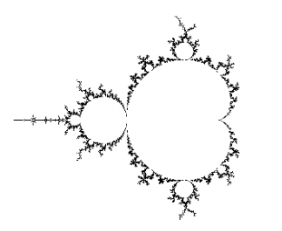Have you ever wondered some more dimensions that are beyond three dimensional space may be something in four dimension and beyond that as well, moving towards more dimensions will bring to fractrals and dimension theory which focuses upon similarities in nature and chaos, say Julia set Buddha brot is a curious fractal that produces wonderful images of cloudy and colorful nebulas, and is closely related to the Mandelbrot set.

One must question one's existence in this complicated web of multidimensional space and time. What are you now, what were you before, what will you be years from now. One must think about it. Everything is present at once.

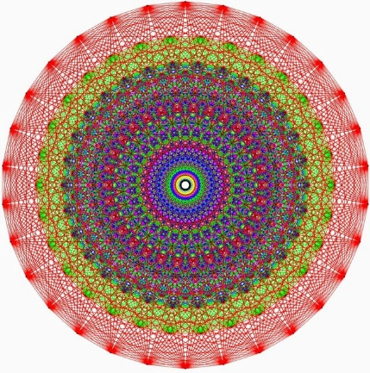You must have heard about E8 lattice most beautiful structure, Mathematicians discovered a complex 248-dimensional symmetry called E8 in the late 1800s, dimensions in the structure are necessarily spatial but they represents a mathematical degrees of freedom, where each dimension is actually different variable.

As we talked about E8 lattice, string theory plays a crucial role, which is actually theory of everything a model that describes all known particles and forces, it is a theoretical framework which focuses on a point-like structure particles of particle physics are replaced by one-dimensional objects which is string.

String theory describes how these particles i.e strings propagates through space and interact with others which is simply the study of n-dimensional space.

These dimensional space studies are actually

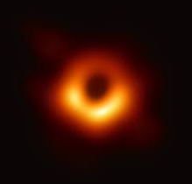Lets talk about pictures of space, sun, aurora borealis, other celestial bodies aren’t there capture a gift of computer graphics. How can we forgot capture of black hole, moving little deep into this NASA mentioned in an article that their scientist theorized they can capture image of black hole by calculating silhouettes but the ability to image an object so distant still eluded them, they created a network telescope i.e Event Horizon Telescope.

MIT American scientist Katie Bouman phd student computer science and artificial intelligence also suggested and algorithm to capture image of black whole. Now NASA team used a technique which is VLBI very long baseline interferometry, which with numbers of computer algorithms used for sorting and synchronizing data.

We can say how computer graphics helped in capturing super massive black hole.